**1.ReactJS-HOL**

**App.js**

import React from 'react'

function App() {

return (

<div style={{alignItems:'center'}}>

<h1 >Welcome to the first session of React</h1>

</div>

);

}

export default App;

**Index.js**

import React from 'react';

import ReactDOM from 'react-dom';

import './index.css';

import App from './App';

import reportWebVitals from './reportWebVitals';

ReactDOM.render(

<React.StrictMode>

<App />

</React.StrictMode>,

document.getElementById('root')

);

// If you want to start measuring performance in your app, pass a function

// to log results (for example: reportWebVitals(console.log))

// or send to an analytics endpoint. Learn more: https://bit.ly/CRA-vitals

reportWebVitals();

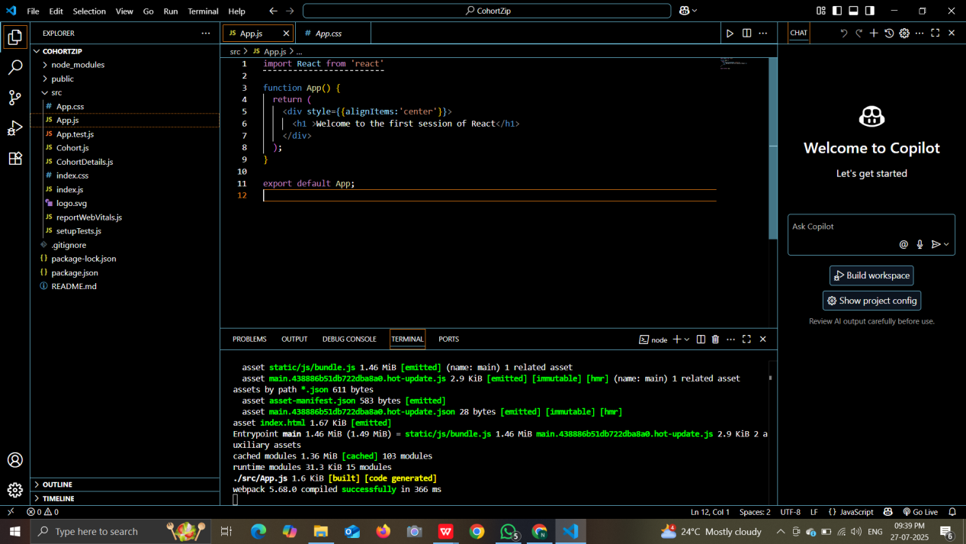

**OUTPUT:**

